Roll No:
Name:

End Semester Examination (Winter 2024)
Invigilator Sign:
Name:
Roll No:

Invigilator Sign:

Branch: 5th Sem, B.Tech. CSE , Course: Operating Systems (CSL309)
Duration: 3 hours Date: 4 December 2024 Max. Marks: 50
Note: Write your name & roll no. clearly and the answers in this paper itself (in the space provided for that question). There are total 6 printed pages. An extra sheet (2 pages) is provided at the end to do the rough work and to carry over any incomplete answer to any question with a note (contd. at the end). Answer the Quiz in OMR Sheets only. Avoid writing answers in the extra page unless really necessary.
Q1 a). What are the two CPU modes of execution? Why are these modes important in CPU Virtualization?

b) Consider the set of processes with given information. In case of tie, the first arrival process is scheduled. The difference between the average turn around time using FCFS and SRTF scheduling is? [2+2=4m]

Process | A | B | C | D
Arrival Times | 1 | 2 | 5 | 8
Burst Time | 3 | 3 | 1 | 3

Q2. Consider a (hypothetical) version of OS that has a page size of 32 bytes, virtual address space of the process has 1024 pages, and the physical memory consisting of 128 pages. Assume that system uses a multi-level page table. The size of the page table entry is one byte that consists of the frame number and a valid bit. Answer the following questions. [1 +2 +2 =5m]
a) What is the total number of pages that are required to store the page table entries of a process, across all levels of the page table?

b) How many pages of memory would this multi-level page table structure use, if the entire address space has just one valid page in it ? Explain.

c) The page directory is found in page 81 of the physical memory. Its contents are given below.
84 fb 8b b7 e4 fe 7f ec b9 d2 d9 ca 90 b4 f0 86
E3 7f 99 a4 a2 7f aa 83 d3 e7 7f bb eb a5 82 7f
How many invalid entries does this page directory contain?

Q3. a) If the time to service a page fault is on average 10ms and the memory access takes 1 µs, then 99.99% hit ratio results in average memory access time of …………. ? [2 m]

b) Assume that you have a page-reference string for a process with m frames (initially all empty). The page-reference string has length p; n distinct page numbers occur in it. Answer the below questions for any page replacement algorithms with justification. i) What is a lower bound on the number of page faults? ii). What is an upper bound on the number of page faults? [2m]

Q4. A certain computer system has the segmented paging architecture for virtual memory. The memory is byte addressable. Both virtual and physical address spaces contain 2^16 bytes each. The virtual address space is divided into 8 non-overlapping equal size segments. The memory management unit (MMU) has a hardware segment table, each entry of which contains the physical address of the page table for the segment. Page tables are stored in the main memory and consist of 2 byte page table entries. What is the minimum page size in bytes so that the page table for a segment requires at most one page to store it? [4m]

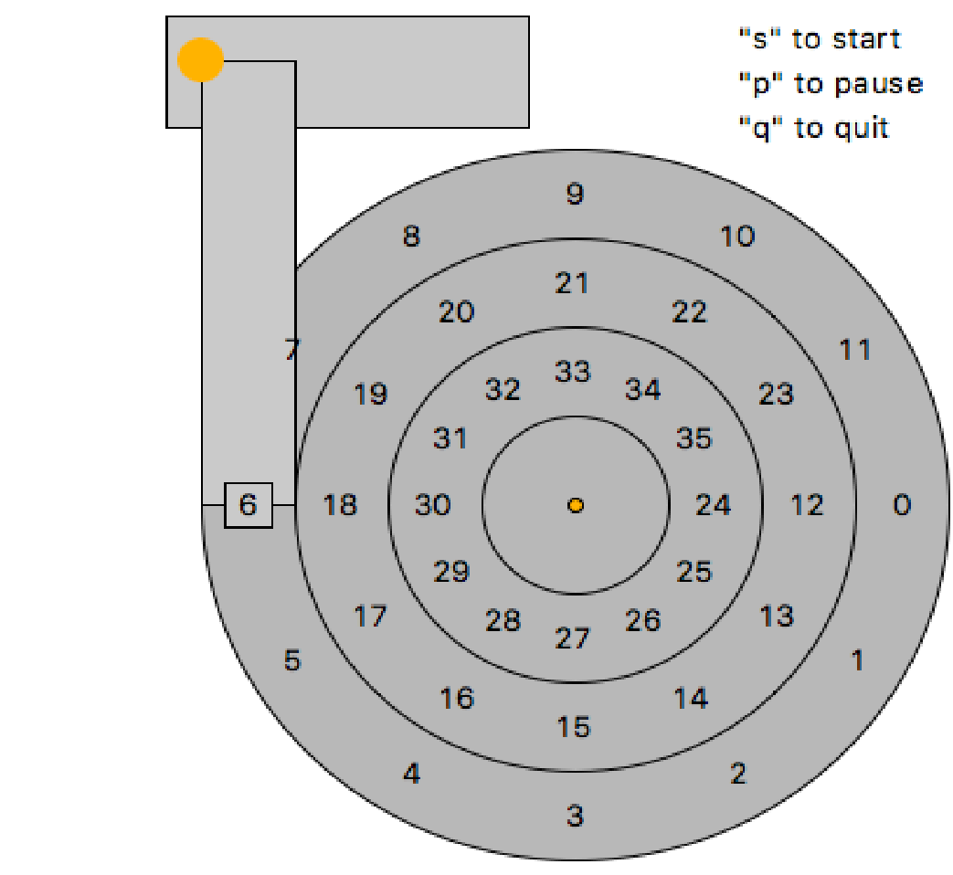
Q5 a) With the current head position of disk as shown in the figure and for an I/O request stream of reading blocks 13, 4, 35, 34, 5 what will be the order for the following scheduling policy assuming VERY FAST seek: i) SSTF (shortest seek first) ii) SATF (shortest access first). [2m]

b) A certain disk-storage device has the following specifications: Number of tracks per surface =4004, total no. of surface = 20, Track storage capacity =13000 bytes, Disk speed =3600 rpm Average seek time =3 ms. Estimate the average latency, the disk storage capacity and the data transfer rate per track.[3m]

Q6. Consider the process of opening a new file “/bar/foo.txt” (assuming it exists), via the “open” system call. a) State the sequence of operations done on all the disk-based file system structures. [1.5m]

b) Briefly state changes to all the in-memory and disk-based file system structures (e.g., file tables, inodes, and directories) that occur as part of this system call implementation. Write clearly, listing the structure that is changed, and the change made to it. [1.5m]

Q7. Three friends go to a Chinese restaurant at 8 pm (Busy time). So, waiter apologizes and says he can provide only 2 pairs of chopsticks (i.e., four chopsticks), which need to be shared between them. They come up with an idea to put all four chopsticks in an empty glass at center table & each diner should obey the following protocol: [2+2=4m]
while ( ! had_enough_to_eat() )
{ acquire_one_chopstick(); acquire_one_chopstick(); //2 times call to acquire
eat();
release_one_chopstick(); release_one_chopstick(); //2 times call to release
}
a) Can this plan lead to a deadlock? Explain your answer.

b) Suppose, now instead of 3 diners, we have 'D' number of diners. Furthermore, each diner may require a different number of chopsticks. Let's say 'C' number of total chopsticks will satisfy the needs of all diners. What is the smallest number of chopsticks (in terms of C and D), needed to ensure that deadlock cannot occur? Explain your answer.

Q8. a) State 2 main benefits of multithreading? What are the possible sources of overhead associated with multithreading? [3m]

b) In a boss-worker’s multithreading pattern, you have one boss (producer) thread and n worker/consumer threads. For each task that enters the system, the boss dispatches the tasks that the workers consumes. This is often done through a shared request queue/buffer. In this case, the boss will add items to the queue, and the workers will consume items from the queue. What could you do to improve a performance metric like throughput or response time, and what are the limiting factors in improving performance in this type of multithreading pattern? [3m]

Q9. There is a bridge across a crocodile-infested river. Halfway across is a platform with a pile of gold bricks on it. The only way to reach the gold is to go through a gate, walk onto the bridge, collect one gold brick, and return to the gate. The gate is initially open, but if a person walks onto the bridge without first ensuring that another person is holding the gate open, then the gate will slam shut, and the person on the bridge will starve. Also, if two or more people are on the bridge at the same time, the bridge will break, and the crocodiles will NOT starve! After a person takes the last gold brick, no other people should walk on the bridge. You have available the following atomic functions (that is, you do not have to write these functions): start_holding_gate (), stop_holding_gate (), and cross_bridge_and_get_gold ()
A person is considered to be holding the gate if and only if s/he has called start_holding_gate() and has not subsequently called stop_holding_gate() . The cross_bridge_and_get_gold() function returns TRUE if and only if there is still more gold (HINT: You do not have to keep track of how many bricks there are). A number of people will come to get gold. You must write a function for each person to call. It must be ensured that everyone who arrives (except the last) will get one gold brick. Also, your function should ensure that if enough people come, nobody will be left waiting forever. You must use semaphores ONLY. You can initialize the semaphores to any values you like, and you may make assumptions about the scheduling of processes waiting on semaphores. These assumptions must be clearly stated. [5m]

